# freETarget

Application Note: Shooting Table

**SUMMARY**

This application note covers the construction of a shooting table based on the equipment used at the US Olympic Training Centre. The main features are:

* Left – Right table position
* Equipment Shelves
* Compact
* Made to be built from standard sized materials

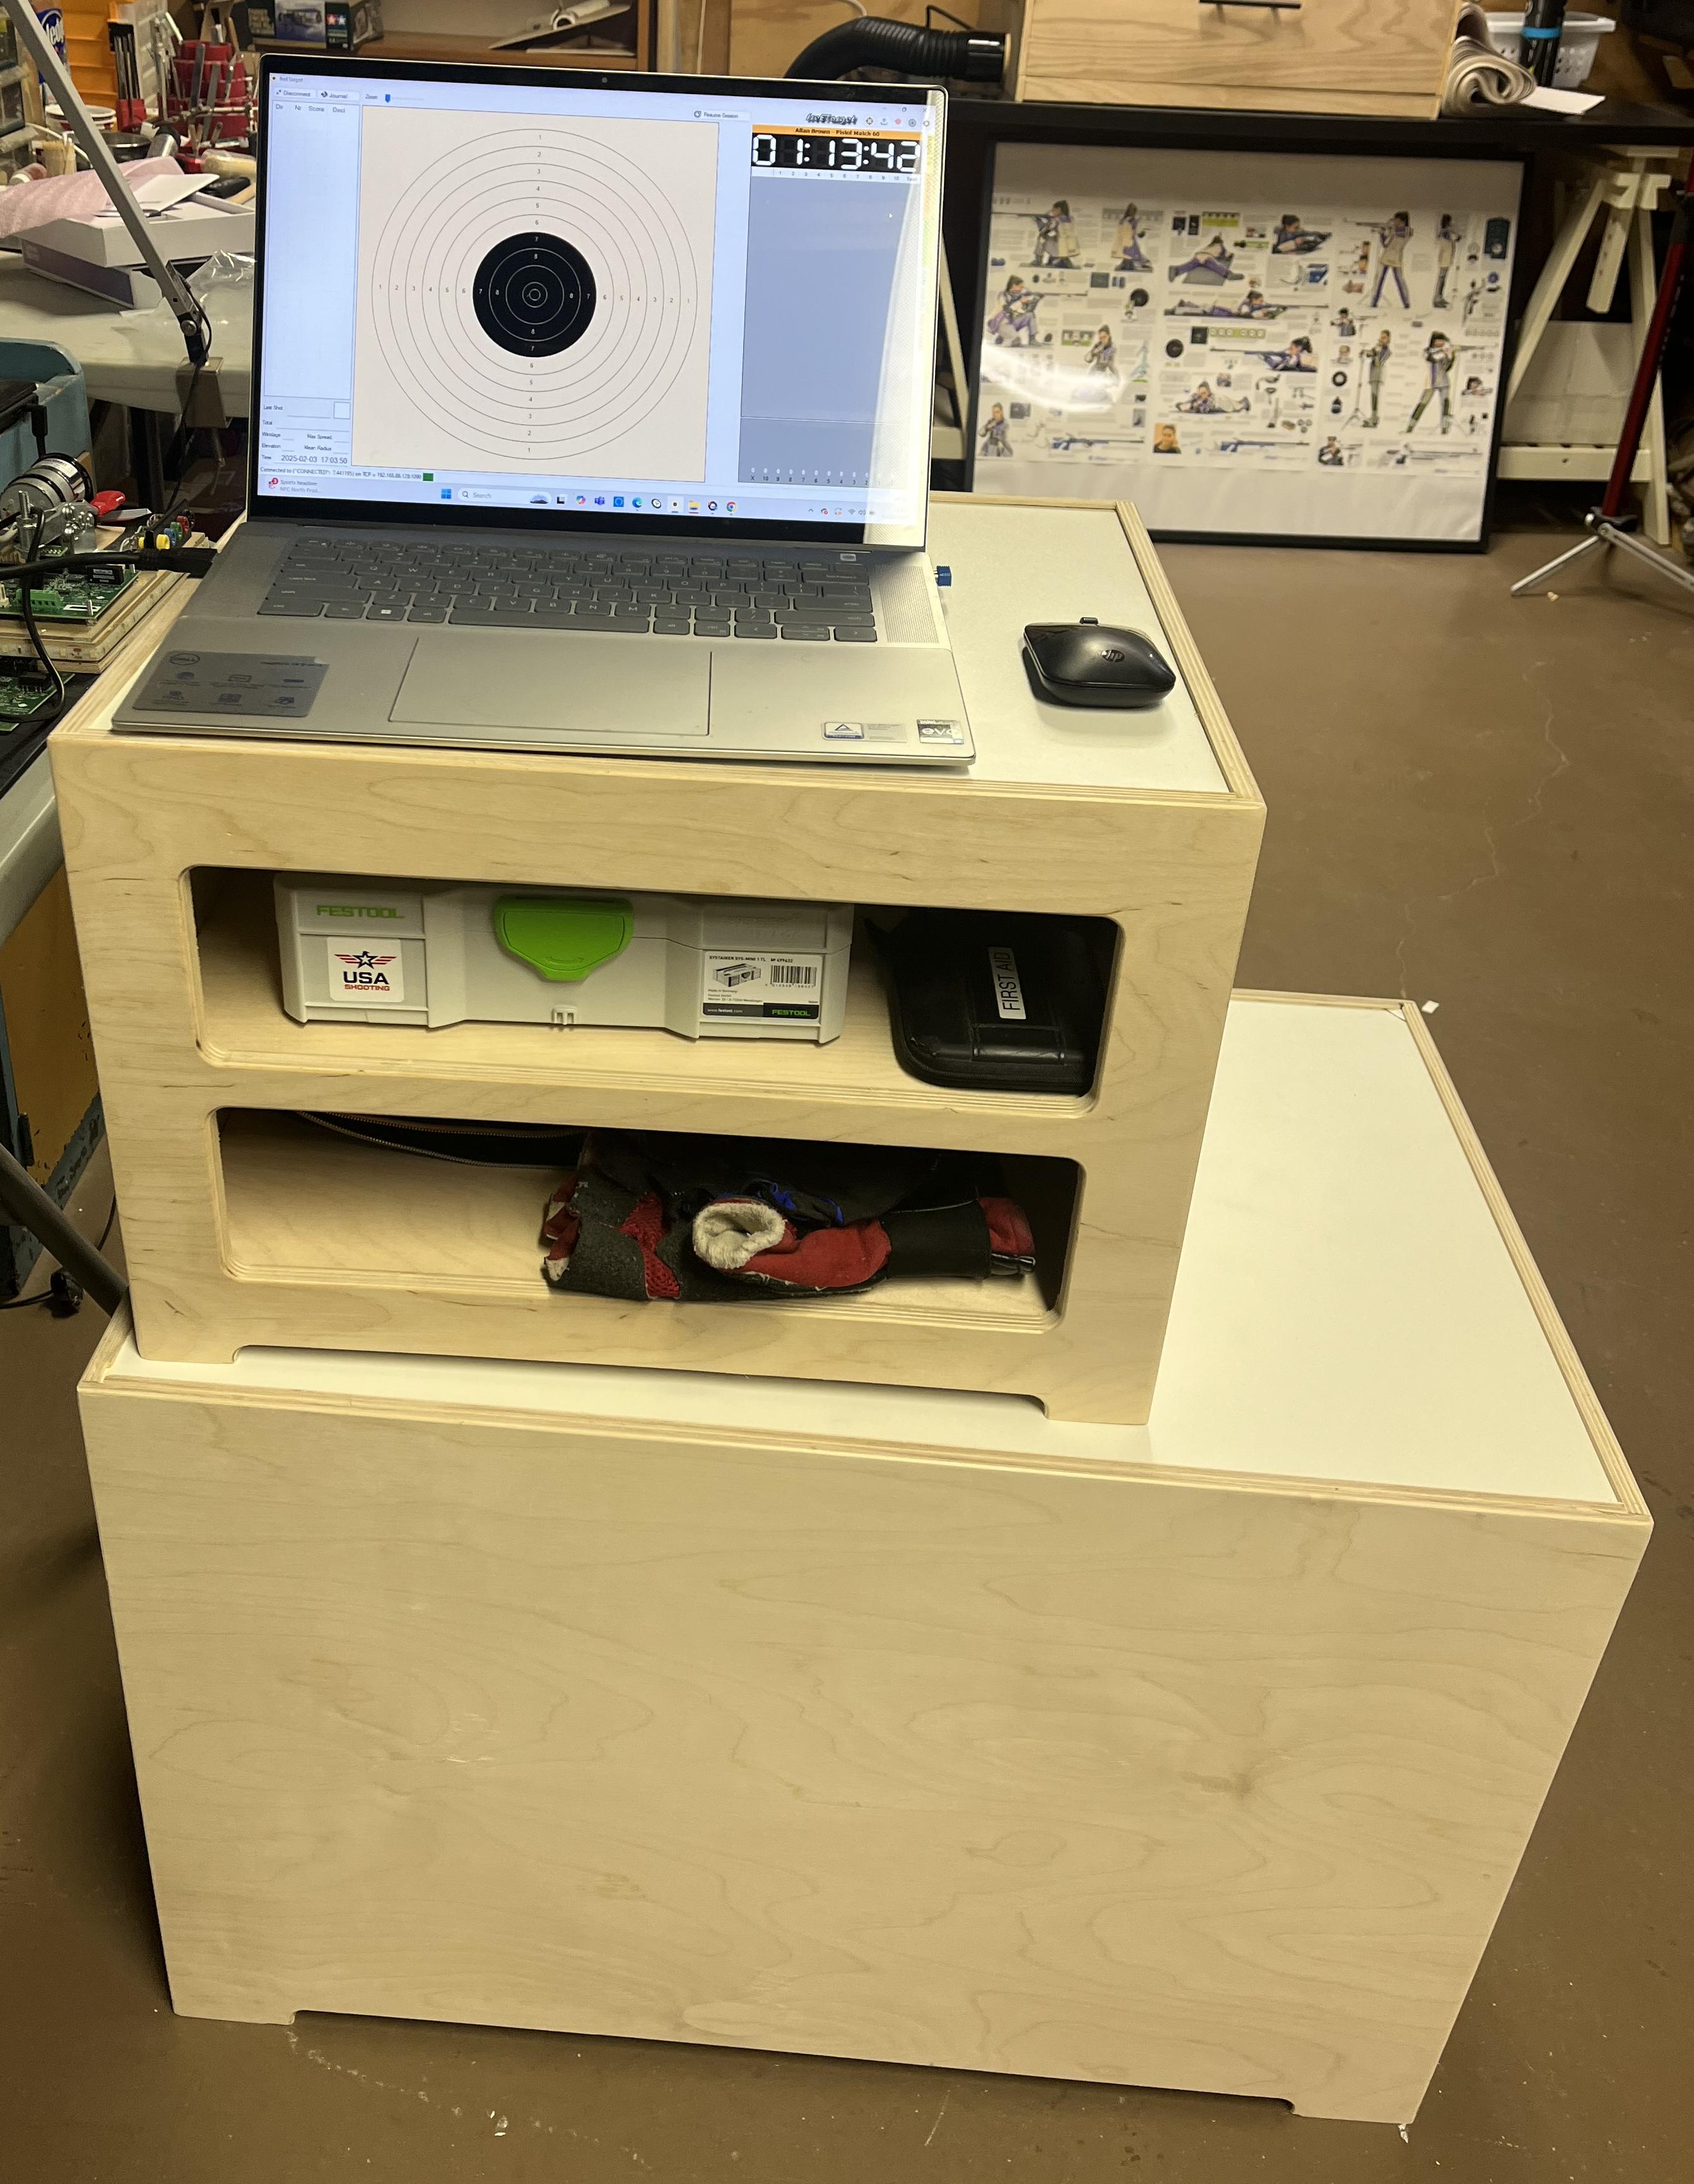

The shooting table is made in three parts

* Base assembly, roughly 750 mm long x 500 mm tall x 475 mm deep
* Top assembly, roughly 500 mm long x 350mm tall x 410 mm deep
* Optional interior shelves, two shelves, approximately 490mm x 410 mm

The table is designed to be made from a single piece of 5’ x 5’ x ½” plywood, and 4’ x’ 2’ x ¾ melamine shelving material. If you decide to add the interior shelves, you will need an additional 4’ x 2’ x ½” piece of plywood.

When finished, the top assembly will fit inside of the base for reduced storage.

IMPORTANT

**This project requires carpentry skills**.

The dimensions given in the appendix are approximate and do not consider any variations in material dimensions or cutting kerf.

This project is best built by adding recess grooves on the inside to fit the panels together. This requires skill in using a router to make the grooves in the right location. If adding grooves, it is recommended that the grooves be at least 5mm (1/4”) away from the edge. Otherwise the edges will separate from the main part (don’t ask me how I know).

**CAUTION**

**This project involves cutting tools that may be dangerous if not used properly.**

**Exercise caution when cutting wood or other materials**

**REQUIRED**

* Plywood Sheet, 5’ x 5’ x ½”
* Melamine Sheet 4’ x 2’ x ¾”
* Plywood Sheet 4’ x 2’ x ½”
* Glue

**ASSEMBLY**

**Base**

Begin by cutting the base and top parts as shown in Appendix 1

Make sure that all of your cuts take the blade thickness into account

Test fit the base panels to determine the opening for the base shelf

Cut the base shelf to match the space for the shelf

Glue the sides together using the shelf as a guide

Glue the shelf to the sides

Using scrap plywood, make reenforcing triangles to be glued on the inside to prevent breakage

**Top**

Test fit the top panels to determine the opening for the top shelf

Cut the base shelf to match the space for the shelf

Glue the sides together using the shelf as a guide

Glue the shelf to the sides

Using scrap plywood, make reenforcing triangles to be glued on the inside to prevent breakage

**Optional Interior Shelves**

Cut the interior shelves to match the space for the shelf

Carefully glue in the high shelf to the inside of the top assembly

Using scrap plywood, make reenforcing triangles to be glued on the inside to prevent breakage

Wait for the high shelf glue to dry and repeat the process on the low shelf

**APPENDIX 1**

**Plywood Panels**

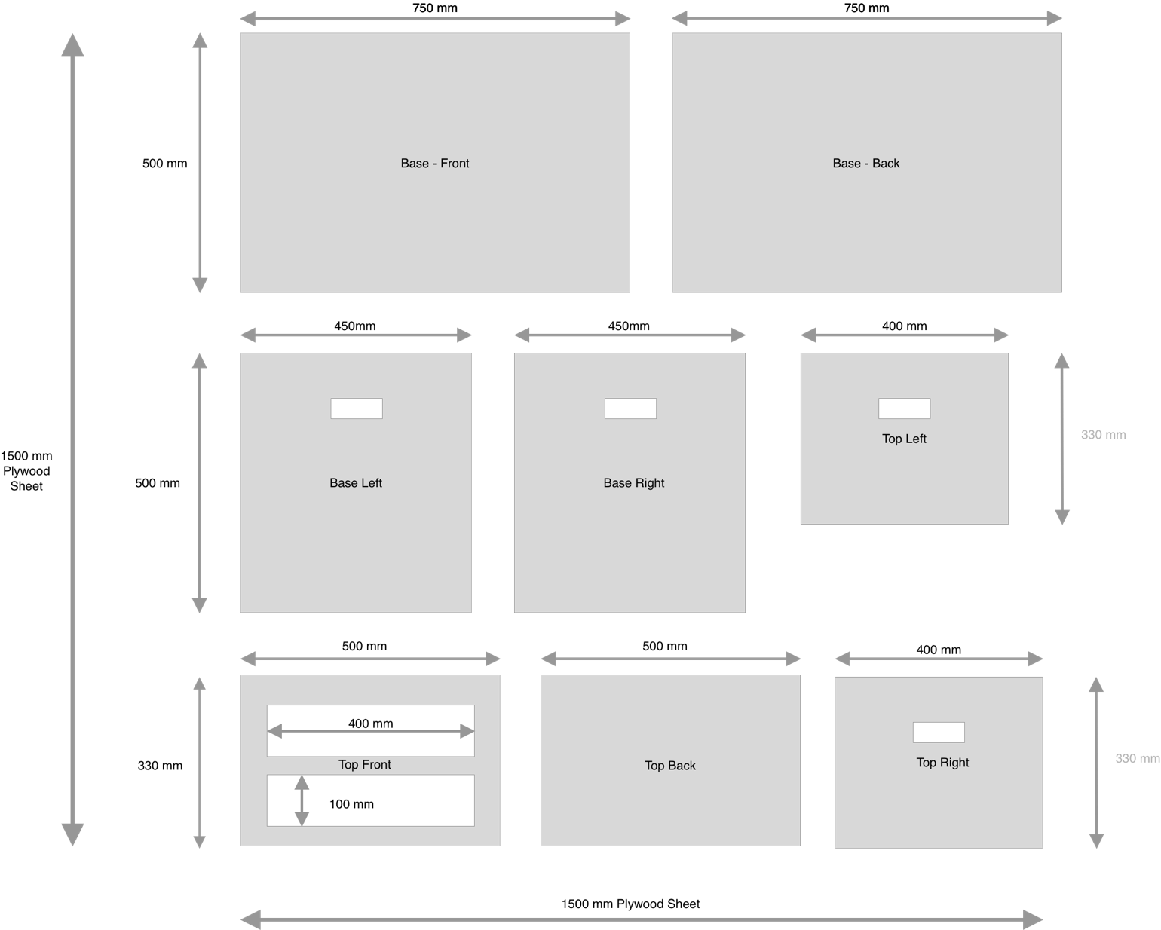

**Melamine Shelves**

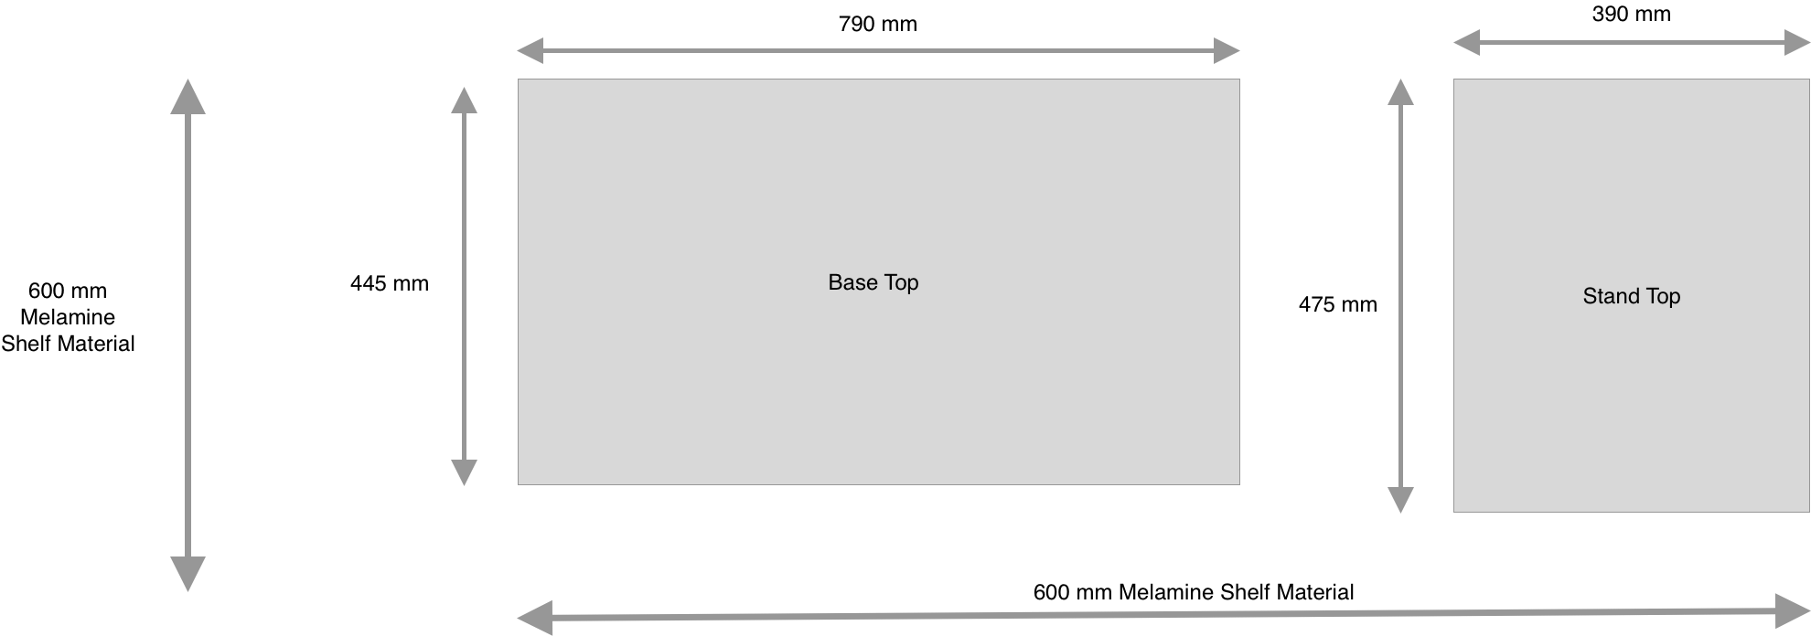

**Interior Shelves -Two Required**

